**Resource group created by RestApi/POSTMAN**

**Prerequisites: Download Postman** - <https://www.postman.com/downloads/>

1. **CLI/Power shell login and find the subscription id**

Example- az account list --output table



086881a8-7090-4e5f-bf0d-57a5d2ab4aa5

1. **Postman**

Put [https://management.azure.com/subscriptions/YOUR_SUBSCRIPTION_ID/resourceGroups<resourcegroupname>?api-version=2021-04-01](https://management.azure.com/subscriptions/YOUR_SUBSCRIPTION_ID/resourceGroups%3cresourcegroupname%3e?api-version=2021-04-01)

Example: https://management.azure.com/subscriptions/086881a8-7090-4e5f-bf0d-57a5d2ab4aa5/resourceGroups/satyapostman?api-version=2024-11-01

1. **Params**

api-version 2024-11-01

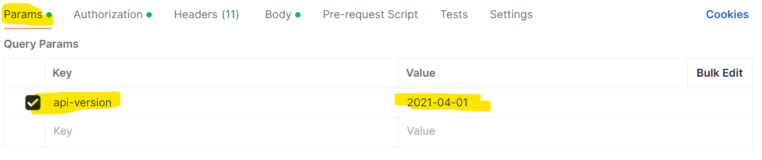

1. **Authorization**

Type ---Bearer Token| <Token>

Find Token: az account get-access-token --query accessToken --output tsv

Example: eyJ0eXAiOiJKV1QiLCJhbGciOiJSUzI1NiIsIng1dCI6ImltaTBZMnowZFlLeEJ0dEFxS19UdDVoWUJUayIsImtpZCI6ImltaTBZMnowZFlLeEJ0dEFxS19UdDVoWUJUayJ9.

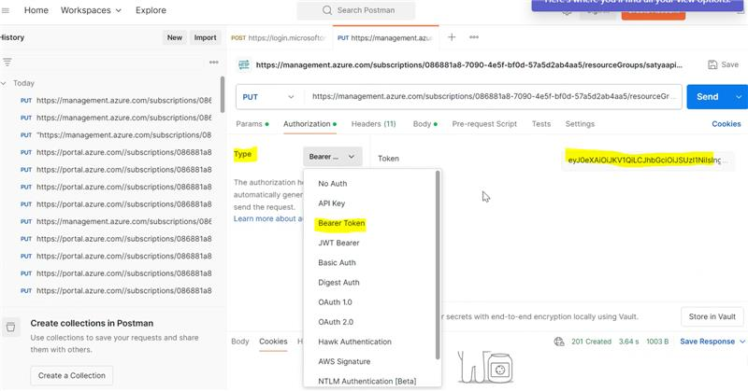

1. **Headers**

Authorization Bearer <token>

Content-Type application/json

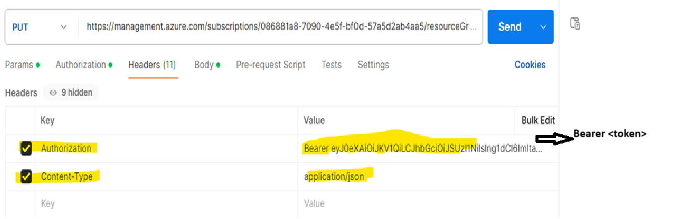

1. **body**

{

"location": "eastus",

"tags": {

"environment": "developer",

"owner": "satyasin"

}

}

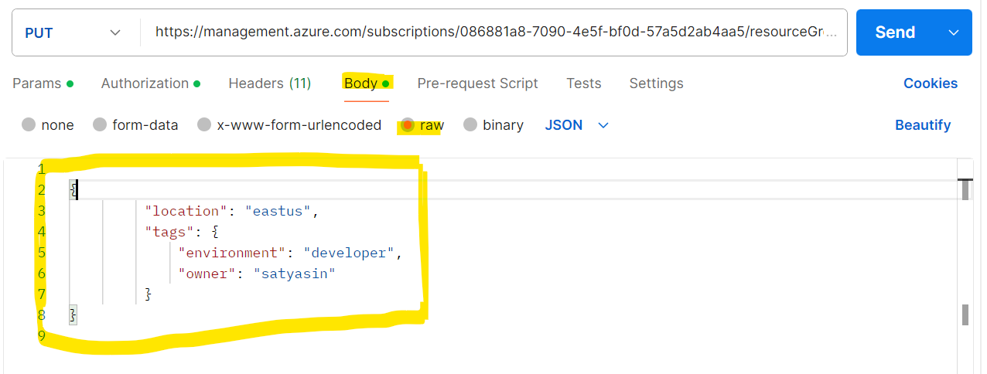

1. **Result -**

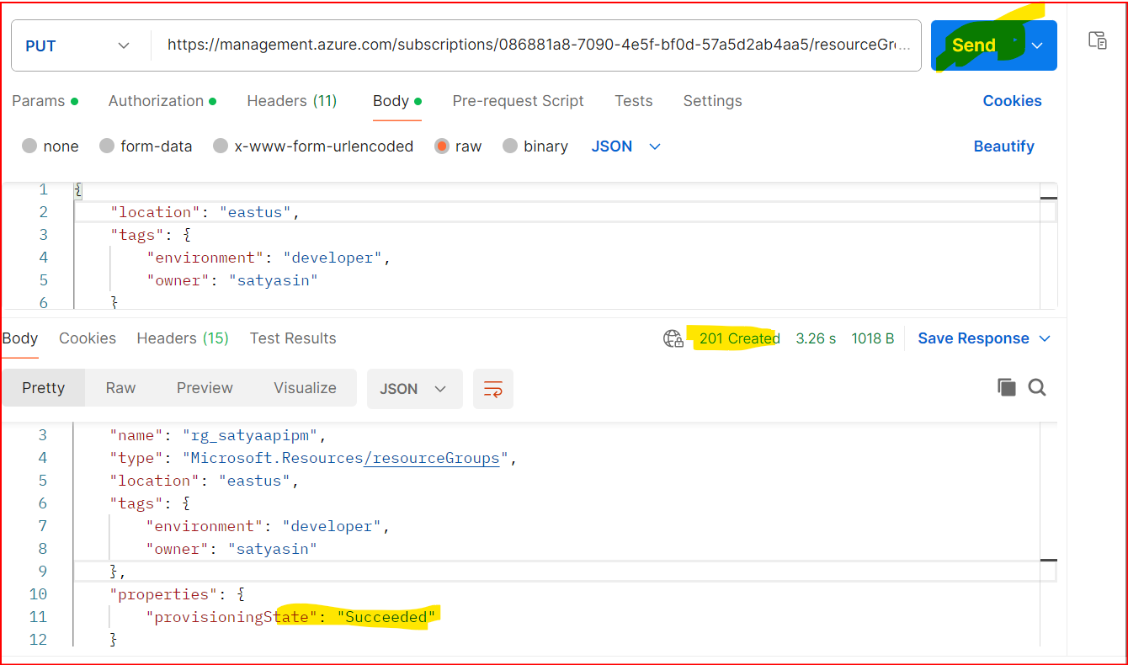

**Go to Azure Portal and check Resource Group**

**What is Postman?**

**Postman is a powerful API development tool that helps developers test, debug, and document APIs effortlessly.**

**It's widely used for sending API requests, automating tests, and collaborating on API development.**

**Think of it as a browser for APIs, where you can send requests (GET, POST, PUT, DELETE) and see responses without writing a single line of code.**

**Working with APIs**

**🔹 Authorization – Set API keys, OAuth, or Bearer Tokens**

**🔹 Headers & Body – Add request headers & JSON body**

**Resource group created by RestApi**

**az login**

**az account show --output table**

**az group list --output table**

**az account list --output table**

**PS C:\Users\hp> az account list --output table**

**Name CloudName SubscriptionId TenantId State IsDefault**

**---------- ----------- ------------------------------------ ------------------------------------ ------- -----------**

**Free Trial AzureCloud 086881a8-7090-4e5f-bf0d-57a5d2ab4aa5 37757ac0-7db0-4d6c-976f-d5eb3c7ad24e Enabled True**

Find Token: az account get-access-token --query accessToken --output tsv

**# 1Get authentication token**

**$token = az account get-access-token --query accessToken --output tsv**

**# 2️ Define required variables**

**$subscriptionId = "086881a8-7090-4e5f-bf0d-57a5d2ab4aa5"**

**$resourceGroupName = "satyargrestapi"**

**$location = "westus"**

**$apiVersion = "2020-06-01"**

**# 3️ Set API URL with the correct subscription ID and resource group name**

**$apiUrl = "https://management.azure.com/subscriptions/086881a8-7090-4e5f-bf0d-57a5d2ab4aa5/resourcegroups/satyargrestapi?api-version=2020-06-01"**

**# 4️ Set headers with the token**

**$headers = @{**

**"Authorization" = "Bearer $token"**

**"Content-Type" = "application/json"**

**}**

**# 5️ Define the request body**

**$body = @{**

**"location" = $location**

**} | ConvertTo-Json -Depth 10**

**# 6️ Invoke REST API to create the resource group**

**try {**

**$response = Invoke-RestMethod -Uri $apiUrl -Method Put -Headers $headers -Body $body**

**Write-Output "Resource Group Created Successfully: $($response | ConvertTo-Json -Depth 10)"**

**} catch {**

**Write-Output "Error: $($_.Exception.Message)"**

**if ($_.ErrorDetails) {**

**Write-Output "Details: $($_.ErrorDetails.Message)"**

**}**

**}**

**Result:**

**Resource Group Created Successfully: {**

**"id": "/subscriptions/086881a8-7090-4e5f-bf0d-57a5d2ab4aa5/resourceGroups/satyapsap9i",**

**"name": "satyapsap9i",**

**"type": "Microsoft.Resources/resourceGroups",**

**"location": "westus",**

**"properties": {**

**"provisioningState": "Succeeded"**

**}**

**}**